**NEVI ToxPi Graphical User Interface Tutorial**

1. Open the ToxPi GUI
2. Click on “Add File” and select the “nevi_features.csv” file that you downloaded earlier.

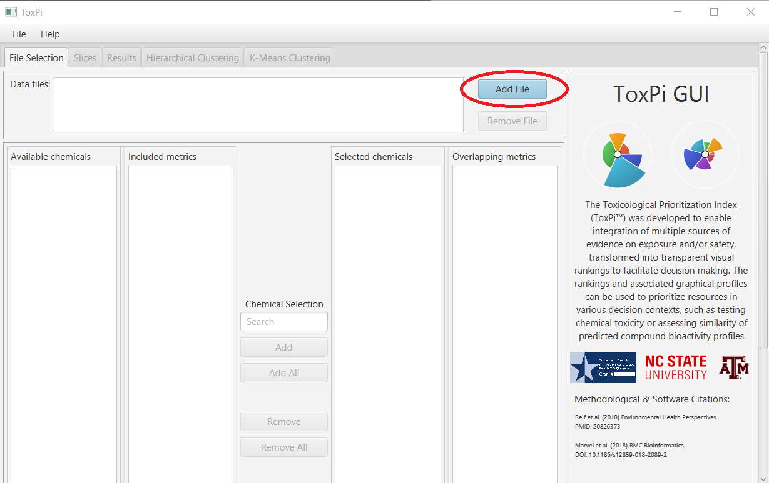

1. Click on “Recreate from File”.

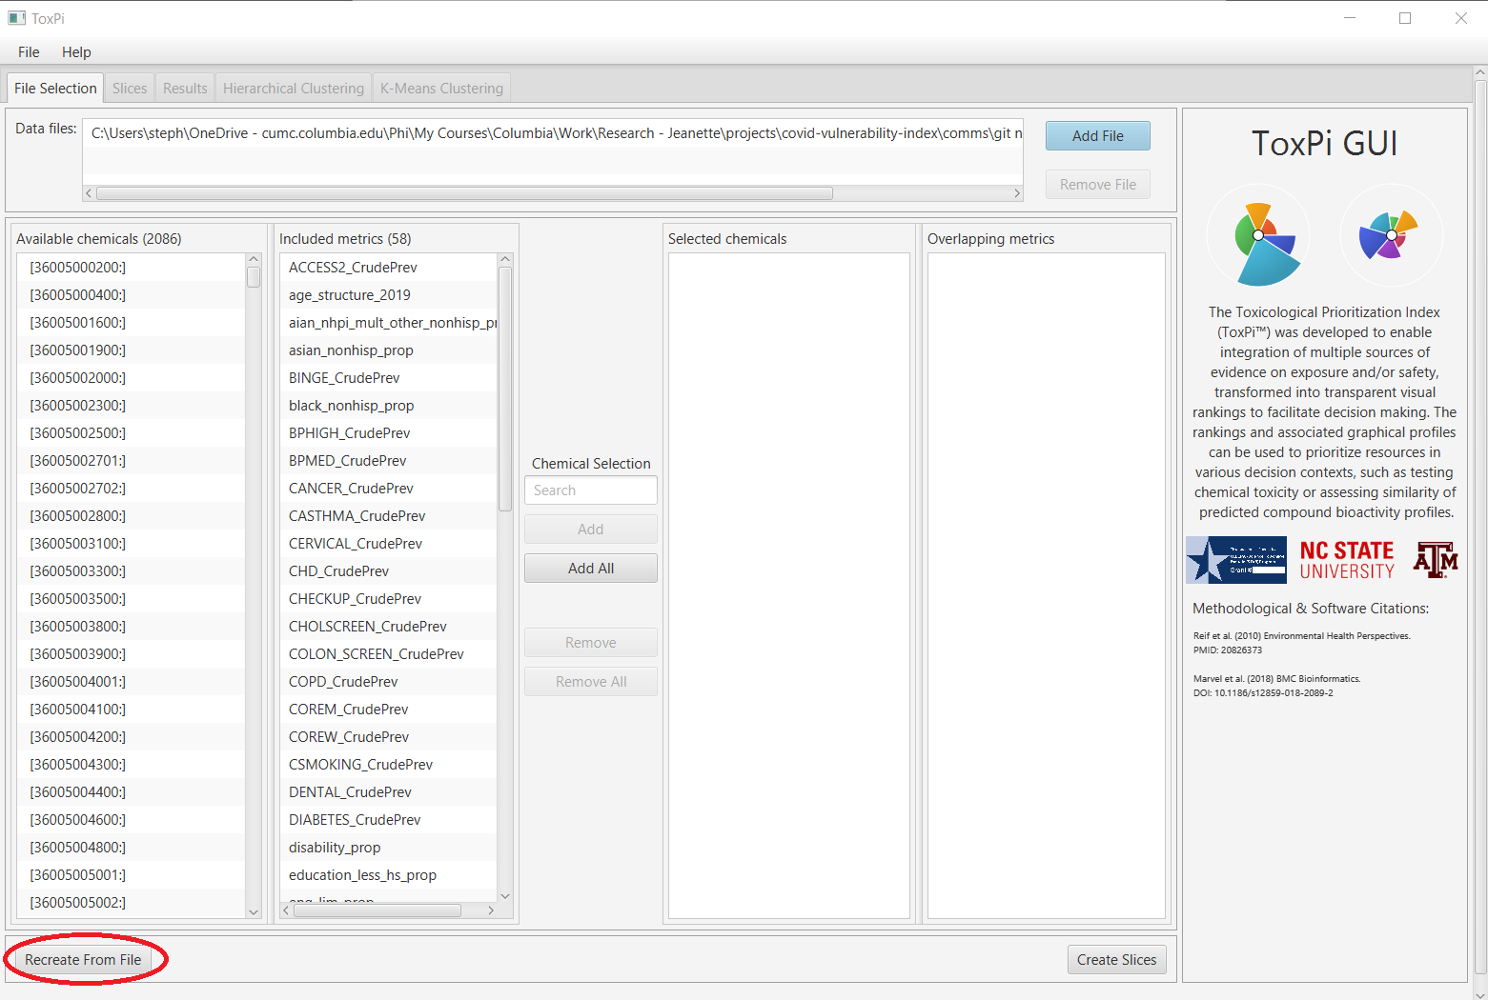

1. Click on “Calculate ToxPi Scores”. It will take a moment to calculate the scores.

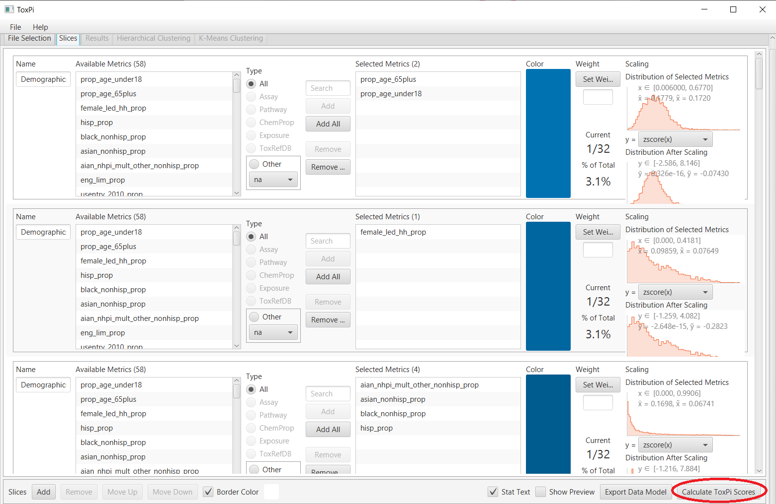

1. Check “Results Table” and click “Save”. Name the export file “nevi_toxpi”.

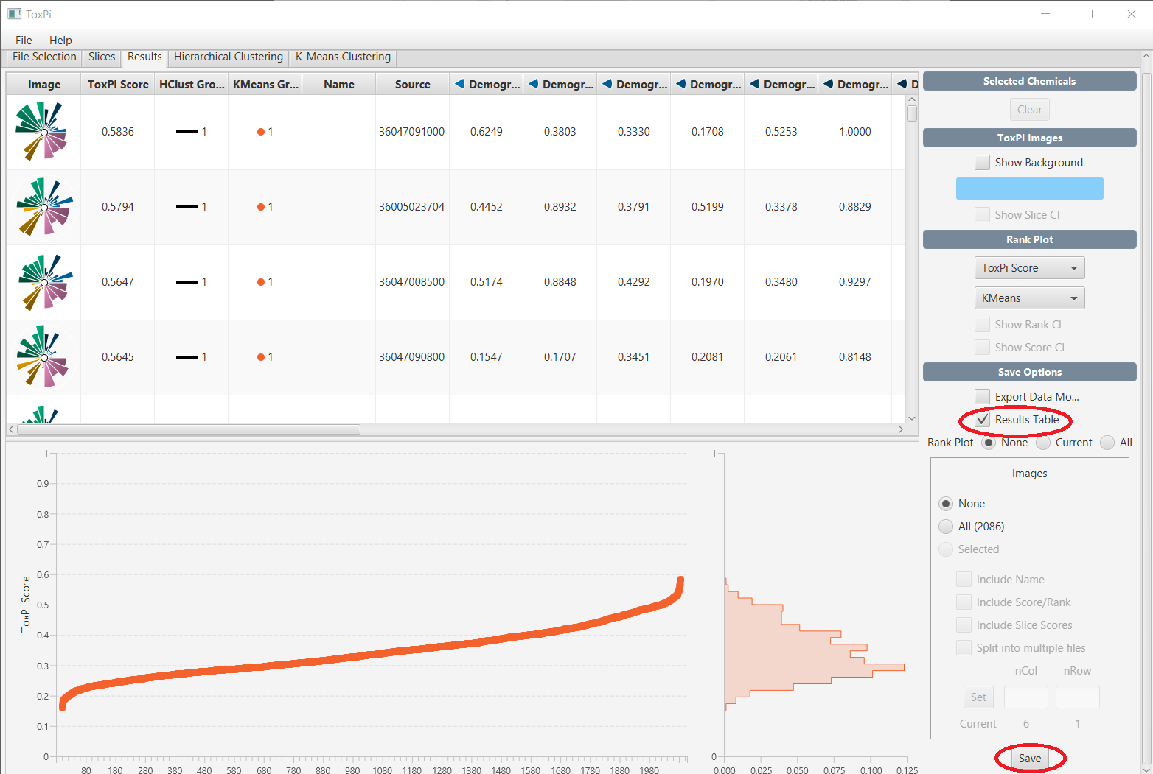

1. You are done! Go back to your R file and continue running the rest of the code.